Name: __________________________ Date:___/___/2016
Grade:____ Period:____
Presidential Election 2016
Third Debate: Info-Sheet & Discussion Guide

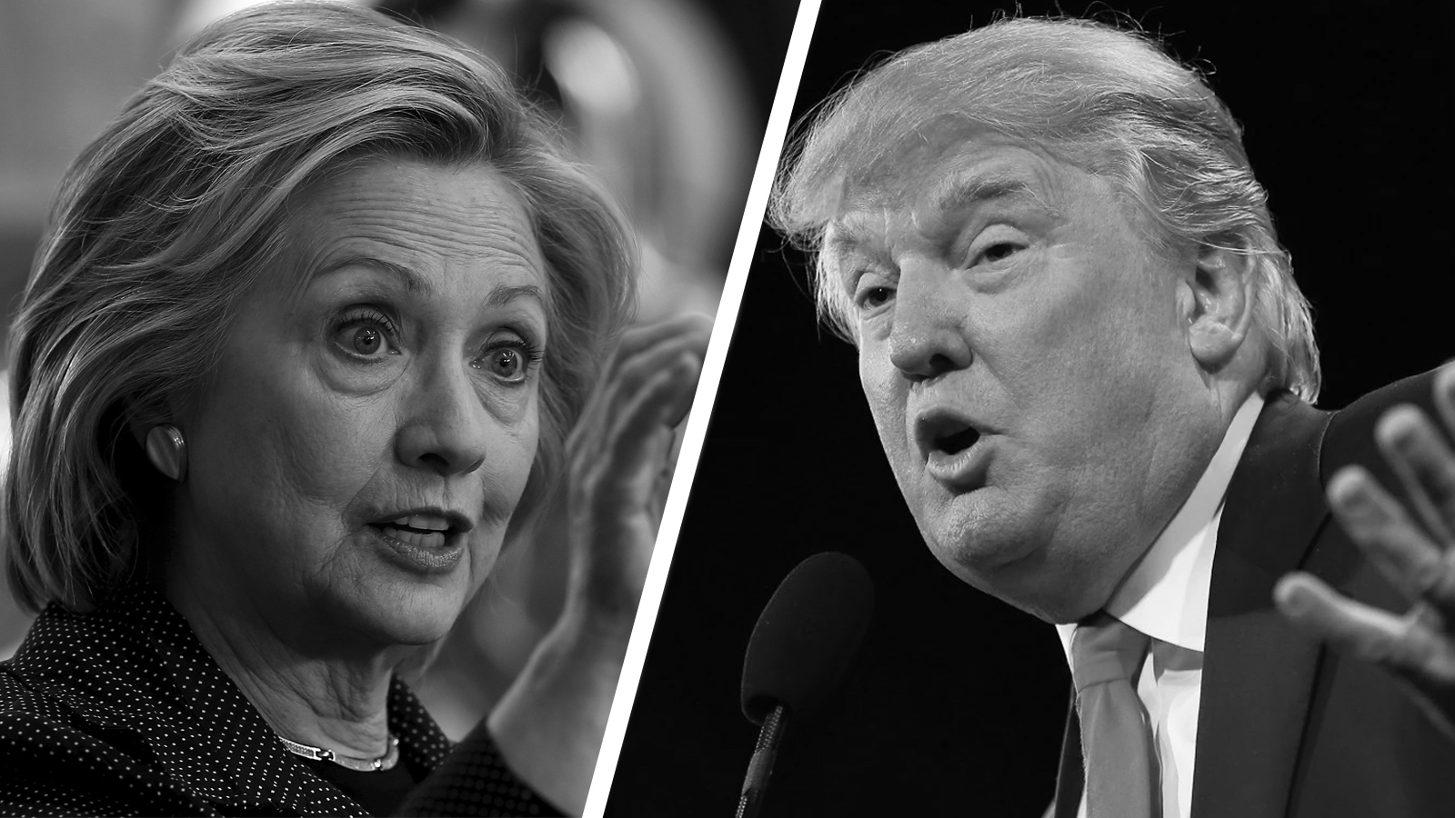

This evening at 8pm, the third Presidential debate between Hillary R. Clinton and Donald J. Trump will air on national television and be made available for live streaming on-line.

Your Assignment: As you watch the debates answer the questions below. Like the first debate, tonight’s debate will be divided into three segments. As you watch the debate select three questions (one question from each segment) and take notes on the moderator’s questions and each candidate’s response. Use the following pages of this packet to organize your notes on each of the questions you selected. Come to class on Thursday prepared for a quick-write and discussion on the debates.

1. Who was the moderator of the debate?

2. Where did the debate take place?

3. What was format of the debate? Was it a formal debate or a Town Hall debate?

4. What were the six topics debated?
1. | 2.
3. | 4.
5. | 6.
Segment: 1

Question: ____________________________________________________________________________________
___________________________________________________________________________________________________________________________________________________________________________________________________________________________________________________________________________________________________
_________________________________________________________________________________________________

1st Candidate’s Answer  Clinton or Trump  (circle one) | Candidate Answer: _________________________________________________  ________________________________________________________________________  ________________________________________________________________________  ________________________________________________________________________  ________________________________________________________________________

2nd Candidate’s Answer  Clinton or Trump  (circle one) | Candidate Answer: _________________________________________________  ________________________________________________________________________  ________________________________________________________________________  ________________________________________________________________________  ________________________________________________________________________

1st Candidate’s Rebuttal  Clinton or Trump  (circle one) | Candidate Response:________________________________________________  ________________________________________________________________________  ________________________________________________________________________  ________________________________________________________________________  ________________________________________________________________________

2nd Candidate’s Rebuttal  Clinton or Trump  (circle one) | Candidate Response:________________________________________________  ________________________________________________________________________  ________________________________________________________________________  ________________________________________________________________________  ________________________________________________________________________

Segment: 2

Question: ____________________________________________________________________________________
___________________________________________________________________________________________________________________________________________________________________________________________________________________________________________________________________________________________________
_________________________________________________________________________________________________

1st Candidate’s Answer  Clinton or Trump  (circle one) | Candidate Answer: _________________________________________________  ________________________________________________________________________  ________________________________________________________________________  ________________________________________________________________________  ________________________________________________________________________

2nd Candidate’s Answer  Clinton or Trump  (circle one) | Candidate Answer: _________________________________________________  ________________________________________________________________________  ________________________________________________________________________  ________________________________________________________________________  ________________________________________________________________________

1st Candidate’s Rebuttal  Clinton or Trump  (circle one) | Candidate Response:________________________________________________  ________________________________________________________________________  ________________________________________________________________________  ________________________________________________________________________  ________________________________________________________________________

2nd Candidate’s Rebuttal  Clinton or Trump  (circle one) | Candidate Response:________________________________________________  ________________________________________________________________________  ________________________________________________________________________  ________________________________________________________________________  ________________________________________________________________________

Segment: 3

Question: ____________________________________________________________________________________
___________________________________________________________________________________________________________________________________________________________________________________________________________________________________________________________________________________________________
_________________________________________________________________________________________________

1st Candidate’s Answer  Clinton or Trump  (circle one) | Candidate Answer: _________________________________________________  ________________________________________________________________________  ________________________________________________________________________  ________________________________________________________________________  ________________________________________________________________________

2nd Candidate’s Answer  Clinton or Trump  (circle one) | Candidate Answer: _________________________________________________  ________________________________________________________________________  ________________________________________________________________________  ________________________________________________________________________  ________________________________________________________________________

1st Candidate’s Rebuttal  Clinton or Trump  (circle one) | Candidate Response:________________________________________________  ________________________________________________________________________  ________________________________________________________________________  ________________________________________________________________________  ________________________________________________________________________

2nd Candidate’s Rebuttal  Clinton or Trump  (circle one) | Candidate Response:________________________________________________  ________________________________________________________________________  ________________________________________________________________________  ________________________________________________________________________  ________________________________________________________________________

